- Background
Zoonoses, or pathogens that spillover from animals to humans, threaten human health and wellbeing^{1,2} and are expected to increase with climate change^{3–5}. Socioeconomic upheaval resulting from climate-induced stressors such as sea-level rise, extreme weather events, temperature changes, food insecurity, and water scarcity will likely drive human migration and increase vulnerabilities as humans seek supportive niche environments^{6,7}. Migration may elevate risk of exposure to zoonotic pathogens, further exacerbating public and animal health concerns⁴. Climate change also stresses wildlife, leading to poorer immune function, increased pathogen shedding^{8,9}, and altered wildlife behavior, leading to closer contact with humans or domesticated animals^{10,11}. Human and wildlife responses to climate change have led to the emergence of deadly zoonoses (e.g., Hendra virus^{12,13}). In the Americas, climate fluctuation has contributed to zoonotic outbreaks and epidemics (e.g., West Nile virus¹⁴, Sin Nombre hantavirus¹⁵), including the emergence of potential pandemic pathogens (Zika virus¹⁶, Plague¹⁷). Here, we propose to build foundational infrastructure to improve early-warning systems of zoonoses across The Americas, shoring up weaknesses in our existing global pandemic preparedness strategy through transdisciplinary, international collaborations with stakeholders and researchers across the natural, medical, and social sciences (Fig 1).

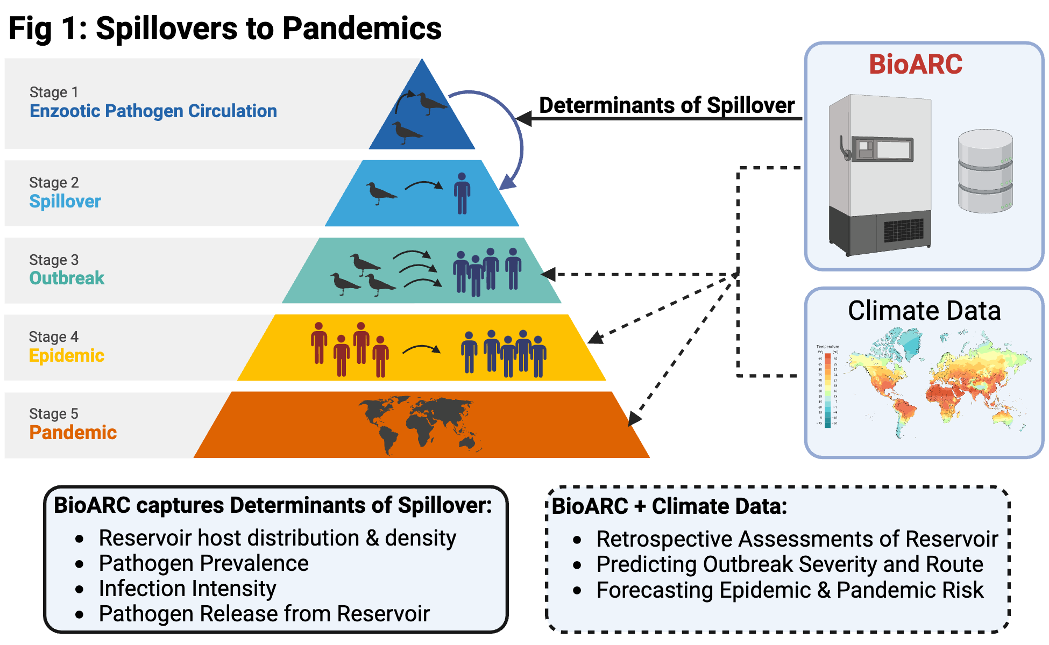

To effectively prevent the devastating economic and health impacts of pathogen spillovers, where assessment and surveillance are often challenging¹⁸, we must extend the One Health framework, where human health is interdependent with animal and environmental health^{19,20}. However, challenges persist in the application of One Health to achieve resilient systems to zoonotic biosecurity threats. Following the findings of previous studies, we split shortcomings in spillover prevention into three major groups: 1) lack of or unequal access to necessary infrastructure²¹, 2) insufficient expertise or communication between experts in different fields^{20,22,23}, and 3) absence of data standards and practices or transdisciplinary workflows^{24,25}. For example, in the recent COVID-19 pandemic, coronaviruses of bats were a known zoonotic threat; coronaviruses had previously spilled over from bats to civet cats to humans (SARS-CoV-1²⁶) and from bats to camels to humans (MERS-CoV²⁷). Human serological surveys in the early 2000s indicated that people may be infected with bat coronaviruses more frequently than previously known^{28,29}. However, there was minimal and unequal investment in broad surveillance of bats for coronaviruses³⁰, information was not readily shared between researchers in the natural and medical sciences³¹, and tissues and genomic sequences were not deposited in open repositories that would guarantee long-term availability of resulting materials and data^{32,33}. These missteps, in part, allowed SARS-CoV-2 to emerge and spread, killing an estimated 3 million people in 2020³⁴ and precipitating devastating setbacks in the fight against poverty²⁰. Vulnerabilities in existing approaches also obstructed reliable and timely identification of the origin and spillover route of this virus, fomenting misinformation and distrust towards experts in pandemic preparedness³⁵. For COVID-19, we had the benefit of many years of prior knowledge and research on coronaviruses that enabled the rapid development of control guidelines, vaccines, and treatments³⁶. We may not be as well informed about the next pandemic-causing zoonosis (e.g., WHO priority Pathogen X), making solutions that empower synergistic action across human, animal, and environmental health an urgent priority.

Biorepositories offer a powerful set of tools to address gaps in spatial and temporal sampling infrastructure, biodiversity expertise, data interoperability, and materials standards³⁷. A biorepository curates and manages diverse biological samples, typically frozen tissues, and associated metadata for use by current and future researchers. Biorepositories are an extension of natural history and medical collections, which have been developing and refining the gold-standard of long-term, open-access specimen curation for hundreds of years^{38–40}. These institutions are inherently designed to offer infrastructure, expertise, and best-practices in sample preservation, data sharing, and interdisciplinary integration to meet the needs of diverse stakeholders⁴¹. Biorepositories are necessary infrastructure for pathogen surveillance, as their ultracold temperatures (>−70°C) preserve nucleic acids and cell cultures that would otherwise rapidly degrade, allowing targeted molecular diagnostic tests and experimental work on pathogens through time⁴². These collections have provided crucial samples and data in identifying the origin of epidemics caused by zoonoses^{43–45} and identifying the environmental drivers of pathogen emergence⁴⁶. Yet, biorepositories have been underdeveloped and underutilized tools in pandemic prevention, despite the vast information they house on zoonoses and their inherent capacity to link data from different sources^{22,47}.

Early-warning system for zoonoses: Our consortium, BIOrepositories for Adaptive Resilience to Climate (BioARC), will create the requisite physical, human, and material infrastructure for an early-warning system for zoonoses in The Americas (Fig 1). Spillovers depend on wildlife reservoir- and vector-pathogen interactions that are often poorly known⁴⁸. Biorepositories are the infrastructure needed to support wildlife surveillance and data curation required for defining these determinants of spillovers in understudied regions or taxa, establishing spatial and temporal change in pathogen dynamics, and feeding predictive outbreak models that allow proactive responses in high-risk areas. These collections grow in value as samples are accumulated, new partnerships are developed, and new questions are addressed. Because biorepositories document temporal baselines, it is essential to establish this infrastructure now so that we can capture how climate and environmental change impact the emergence of pathogens.

In our consortium, we propose to build a network of biorepositories across The Americas focused on wildlife pathogens and then leverage these biorepositories to search for zoonotic threats (Fig 1). Our approach offers a new transdisciplinary framework for biorepositories that will super-charge their value to early-warning systems of zoonoses through co-production of knowledge with academic and non-academic stakeholders. Like many science institutions, biorepositories have a legacy of colonialism⁴⁹. The largest natural history collections were built by extracting biological diversity from places now known as Low- and Middle-Income Countries (LMICs), often with unacknowledged assistance and expertise of local scientists and communities⁵⁰. This biological diversity is primarily housed in institutions in Europe and the United States, where it is most easily accessible to researchers in these countries. Since the United Nations Convention on Biological Diversity⁵¹, international investigations have shifted towards more equitable multinational collaborations. Our proposal contributes toward this shift by helping build infrastructure and capacity in biodiverse countries with in-country experts as leaders, stewards, and users of these collections. Each project goal focuses on co-production of knowledge by academic and non-academic stakeholders for developing more robust and inclusive practices for the collection, curation, and management of biorepositories in the context of diverse regional requirements and priorities.
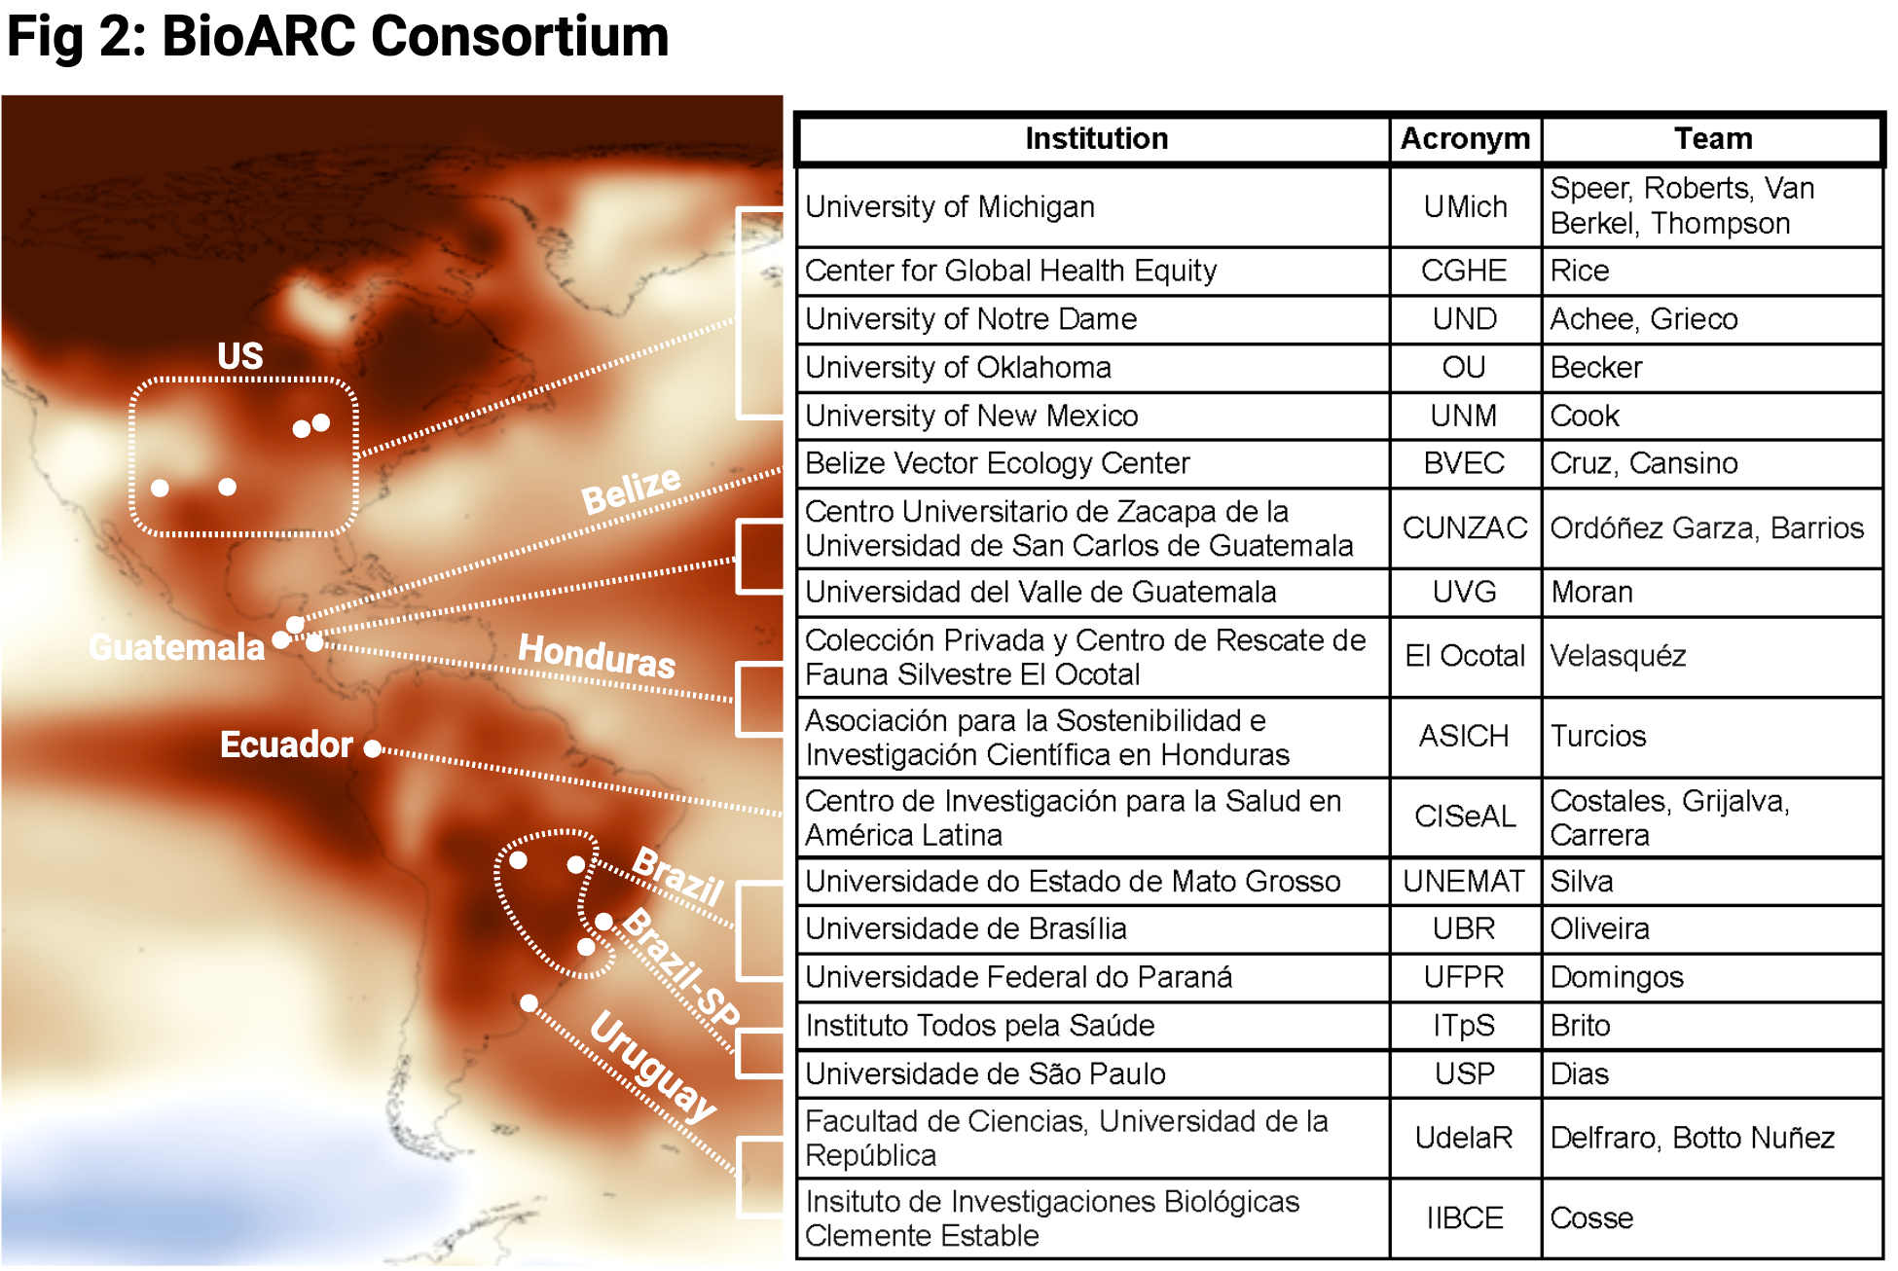
BioARC focuses on The Americas as a test case that we hope to expand in the long-term. BioARC (Fig 2; includes institutional acronyms) includes academic and non-academic experts in the natural sciences, medical and veterinary health sciences, ethnography, geospatial data sciences, data management and sharing, and public health policy and implementation. We are based at universities, civil society organizations, non-governmental organizations, private conservation organizations, and public health organizations. This consortium aims to synergize previously independent efforts to understand how climate is driving infectious disease threats across The Americas by building a network of zoonosis sentinels (Fig 2; change in surface temperature indicated, darkest red is warmer and lightest blue is cooler). Through this distributed framework, we can maintain flexibility for creating local solutions while informing broader predictions and measurements of the ways global climate change may drive disease dynamics. We bring to bear our varied knowledge and perspectives to co-create a cohesive, sustainable, and potent system for keeping human and animal communities safe from infectious diseases.

2. Research Plan
We will co-develop the requisite infrastructure, expertise, and best practices for an early-warning system for zoonoses across The Americas, enabling BioARC team members to more effectively monitor pathogen dynamics as climate change leads to regionally specific effects.

Aim 1: Infrastructure– We will build infrastructure to support efforts by both biodiversity and public health researchers to mitigate the worst consequences of environmental and climate change (Fig 3). This infrastructure includes purchasing freezers and generators necessary for new biorepositories (Guatemala [GUA], Honduras [HON], Ecuador [ECU], Brazil [BRA]), unifying existing in-country freezer capacity and wildlife sampling as a biorepository (Belize [BZE}, São Paulo [BRA-SP], US, Uruguay [URY]), implementing informatics tools to manage and share specimen data (all countries), and building informatics tools to improve communication between academic and non-academic partners (all countries). These 8 biorepositories will function as a distributed network of individual nodes, led by in-country academic and non-academic partners. In each country, biorepository equipment will be housed in existing buildings and managed by BioARC members. Developing this infrastructure will reduce adaptation costs by building local capacity to collect and preserve the necessary wildlife tissues and data required for proactive or timely responses to spillovers.

All collected specimens will remain in their home country, enabling local ownership over biodiversity data. Each biorepository will maintain their specimen metadata (e.g., locality, host attributes) in the Arctos collection management software (1 database per biorepository), a widely used database management system for biorepositories that enables standardized data entry, data dissemination, and protection of sensitive data^{52–54} (see Impact Plan). Cook will visit BioARC partners to facilitate data migration into Arctos. Following the initial 3 years of funding, we will seek additional partnerships to implement front-end improvements to the user experience of Arctos (see Impact Plan).

We will also develop new tools for allowing community members to contribute observational data to our biorepositories (Van Berkel). Community-sourced data will guide sampling priorities for each biorepository, enabling local ownership in the process of wildlife pathogen surveillance (see Impact Plan).

Aim 2: Expertise– Our goal is to develop expertise across BioARC through a knowledge exchange focused on building capacity to manage biorepository samples and associated databases, engaging local communities and stakeholders, and developing workflows for integrating these biorepositories within local public health decision-making. Infrastructure built in Aim 1 must be accompanied by expertise, ensuring each biorepository collects, manages, and disseminates relevant data to public health researchers and policymakers. Exchange programs will include academic and non-academic instructors, offering many varied sources of knowledge.

We will organize an annual month-long exchange program of small cohorts from each consortium nation to travel to UMich and to 1 other nation (BZE: BVEC in Y1, BRA: UNEMAT in Y2, and ECU: CISeAL in Y3). At UMich, the cohort will receive 2 weeks of training in biorepository management (Thompson), molecular genetics (Speer), disease ecology modeling (Becker), geospatial data analysis (Van Berkel), science communication informed by ethnographic practices (Roberts), and One Health network development (Polson, Achee, Grieco). During their trip to 1 other consortium nation, the cohort will participate in 2 weeks of field work, community workshops (see Impact Plan), and co-development of pathogen surveillance paradigms (Y1: Achee, Grieco, Cruz, Cansino; Y2: Silva, Oliveira, Domingos, Dias, Brito; Y3: Constales, Grijalva, Carrera). Following these exchanges, BioARC partners can recruit and train additional individuals in their efforts to monitor zoonotic threats locally, further sustaining and growing our community of practice.
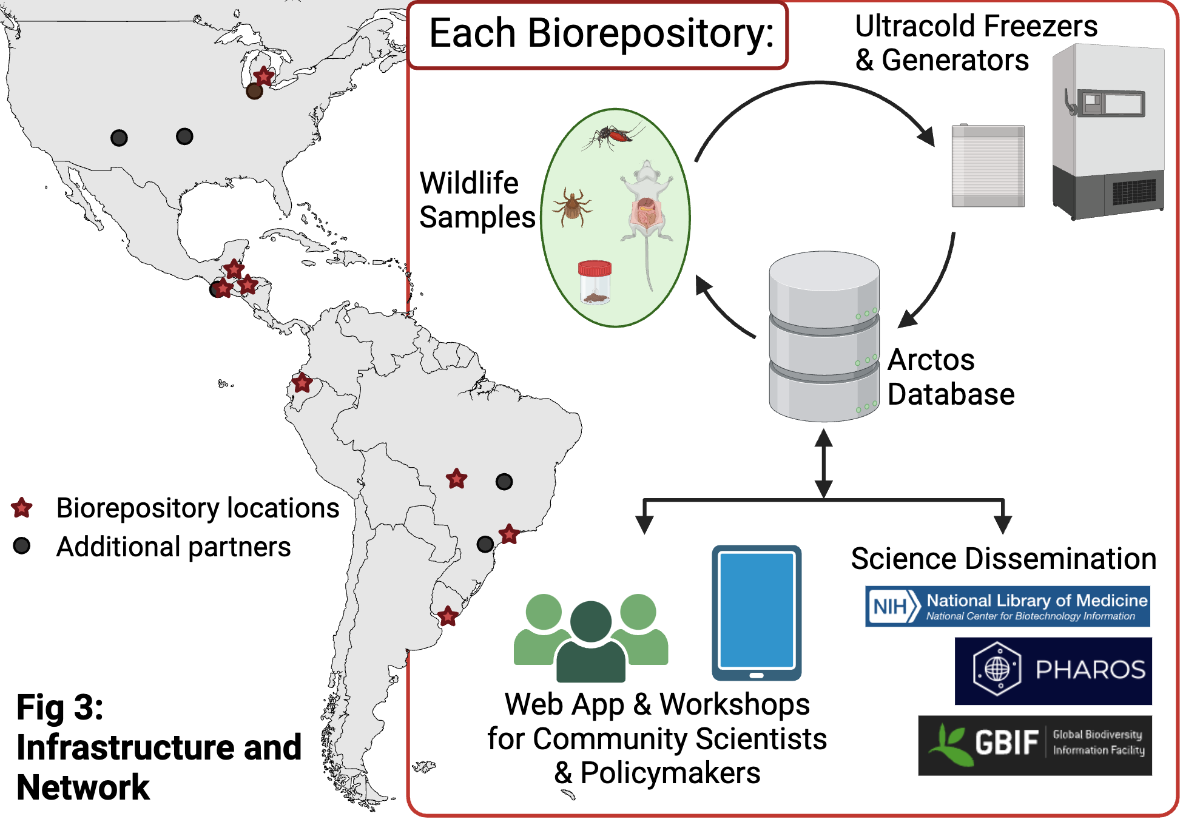
Aim 3: Best Practices– We will co-create best practices for studying wildlife biodiversity and wildlife-associated pathogens to maximize conservation and public health outcomes. Co-production of practices and knowledge will create innovative approaches that better fit BioARC’s varied institutional cultures and experiences⁵⁵, and may increase diffusion of such practices offering the potential for crowdsourcing new types of zoonotic data⁵⁶. Such approaches have been successful in collecting disease outbreak data that is more geographically representative and timely⁵⁷. Best practice development will standardize procedures across BioARC, and facilitate the extension of the BioARC model beyond The Americas. We will publish best practices across 4 topics in F1000Research, enabling us to treat them as living documents that can be progressively updated via community review.

Topic 1: Biorepositories and Relational Databases for Pathogens and Parasites– establish standard operating procedures (SOPs) for sampling, curating, digitizing, and sharing wildlife specimens, and communicating associated host and pathogen metadata and surveillance results to both biodiversity and public health practitioners (see Impact Plan; Thompson, Cook, Ordóñez, Carrera, Botto).

Topic 2: Workflows for Wildlife Pathogen Surveillance and Climatic Drivers– develop detailed workflows for examining the climate impact on wildlife pathogen emergence. Leveraging biorepositories, these guides ensure efficient specimen and metadata curation needed to extract meaningful climatic variables (i.e., sample data and spatial coordinates), facilitating a holistic approach to monitoring wildlife pathogens across various ecosystems and research disciplines, thus enhancing understanding of disease dynamics and promoting effective pandemic preparedness measures (see Impact Plan; Becker, Brito, Cosse, Delfraro, Speer, Turcios).

Topic 3: Improving Communication Across One Health Disciplines– assess discipline-specific cultures. Communicating across disciplines is often difficult because of different terminology, priorities, and duties. To mitigate these challenges, we will carry out a rigorous ethnographic assessment of these differences in real time throughout the project, and publish a best practices paper for both the sustainability of the consortium as well as related One Health efforts (see Impact Plan; Roberts, Dias, FAPESP Postdoc [TBD]).

Topic 4: Strategies for Coordination between Biorepositories and Policymakers– ensure that data produced from BioARC reaches the relevant policymakers. We will conduct a needs assessment of BioARC to identify priority gaps in national wildlife health programs (Y1) and quantify BioARC’s efforts to address these gaps (Y3). Using these formative and summative assessments, and lessons learned during the implementation of BioARC, we will provide evidence-based strategies for integrating biorepositories into national and regional wildlife health decision making (see Impact Plan; Costales, Grijalva, Polson, Sleeman, Cruz).

Reviewer Feedback: We have scaled back our approach to improve feasibility; we now only address Themes 1 and 3. We have also allocated funds to subscribe to the Arctos collaborative for database support, and clarified the expertise of our consortium in database management and bioinformatics. To help us navigate the complex legal landscape for sharing biodiversity data, we have recruited an expert in transnational public health (Polson) and in development of national wildlife health plans (Sleeman)⁵⁸ to join BioARC. We have provided additional background information about the link between climate, environment, and zoonotic threats, and the necessity of biorepositories in documenting wildlife and pathogen response to climate. The reviewers noted an imbalance in the requested funding; we have requested the maximum allowable funding for each BioARC partner. As we are able to request more support from NSF than other annexes, we have allocated almost half of the U.S. budget to support the exchange program and its coordination. We have clarified stakeholder leadership in BioARC and we have further developed the transdisciplinarity of our aims following completion of the IAI-offered module on mobilizing transdisciplinary knowledge and training.

Added Value: Our approach focuses on co-creating missing physical, human, and material infrastructure in the effort to reduce zoonotic biosecurity threats. Our consortium includes both institutions and nations that have a long history of zoonosis research and investment in biorepository capacity along with institutions and nations that do not currently have this infrastructure. Below we describe value-added aspects in more detail.

Strengthening Emergent Pathogen Detection and Mitigation
- BVEC will extend existing in-country biorepository infrastructure and surveillance capabilities to monitor tick-borne pathogens in cattle and detect and prevent outbreaks of food-borne pathogens. This will support BZE’s National One Health Committee, Agricultural Health Authority (BAHA), and Ministry of Agriculture, Food Security and Enterprise, as BVEC partners with these agencies in monitoring and preventing zoonotic disease outbreaks and transmission. BAHA relies on BVEC to provide infrastructure for zoonotic disease detection, utilizing this data to formulate national policies and monitoring strategies.
- CISeAL will bolster ongoing Chagas and malaria research, among others. CISeAL has a robust history in these diseases, with significant influence on public health policy within ECU. Its research efforts directly contributed to the establishment of the National Chagas Disease Control Program by the Ecuadorian Ministry of Health in 2005, along with the inception of the External Evaluation of Performance Program for Blood Banks in 2002. The cryo-bank at CISeAL stores hundreds of isolates and clones from locally circulating Trypanosoma cruzi (causative agent of Chagas disease) as well as related trypanosomatids and dozens of local isolates from Plasmodium falciparum and P. vivax.
- UdelaR has been involved in the identification and characterization of emerging viruses, focused on rodent-borne^{59–61}, mosquito-borne, and bat-borne viruses^{62–65} in Uruguay. IIBCE leadership in the Barcoding of Life initiative is contributing to the taxonomic identification of mammal hosts, facilitating accurate pathogen tracking and biodiversity assessment. The project will enhance existing multidisciplinary approaches that encompass virologists, mammalogists, medical sciences specialists, the Ministry of Health, the Ministry of Agriculture, Livestock, and Fisheries, and emphasizes a strong training component through the inclusion of undergraduate and graduate student researchers. UdelaR will increase capacity for collection and storage by funding field work and development of periodic outreach activities within local communities on conservation, zoonosis, and their prevention and control.

Extending Ongoing Wildlife Sampling and Conservation Initiatives for Zoonosis Mitigation
- In BRA, UNEMAT and UFPR will extend studies of bat ecology and population genetics in the Cerrado-Amazon transition, bolstering 18 years of prior work in 1 of South America's primary deforestation frontiers^{66–68}. UNEMAT will leverage the exchange program and best practices to extend ongoing fieldwork to include a broader diversity of vertebrate species and arthropods, and to use existing lab infrastructure to examine specimens for zoonoses in a region undergoing a significant environmental shift.
- In GUA, CUNZAC and UVG will unify existing wildlife sampling efforts to create a Neotropical-origin pathogen biorepository. We will also increase wildlife tissue collection that to date has not been systematically preserved with associated vouchers to substantially enrich the country's natural history collections, and advance knowledge of potential local epidemiological occurrences. This effort complements our recent projects focused on infectious cycles between wild vertebrates and arthropods with other species (marsupials and ticks⁶⁹), and other disease ecology research based in GUA^{70–72}.
- In HON, El Ocotal & ASICH will preserve host tissues and associated parasites and pathogens through the creation of a pioneering Research Center, the first of its kind in the country. The primary goal is to safeguard neotropical biodiversity in HON. Recent projects underscore the work of ASICH and El Ocotoal as leaders in the conservation of endangered species in HON, particularly mammals^{73,74} and to document associated parasites⁷⁵. Collaborations between ASICH and El Ocotal serve as successful models for the role of non-academic stakeholders as leaders in transdisciplinary efforts, providing a template for partnership initiatives that the biorepository aims to emulate.

Formalizing In-Country Biorepositories with a focus on Pathogens and Parasites
- In the US, proposed activities will synergize efforts to build transdisciplinary solutions to zoonotic threats across UMich, OU, and UNM. Current efforts include tailoring biorepositories to pathogens and parasites through the Michigan Pathogen Biorepository (Speer), Pathogen Informatics Center: Analysis, Networking, Translation & Education (PICANTE!, Cook) and Museums and Emerging Pathogens in the Americas (MEPA, Cook & Thompson), increasing domestic and international pathogen surveillance of wildlife (Becker^{12,76–80}), and using ethnographic practices (Roberts) and geospatial data analysis (Van Berkel) to engage with stakeholders on priority gaps. Through BioARC, we will harmonize our efforts within the US and with international partners to build a more effective strategy to predict and prevent climate-driven zoonoses.
- USP and ITpS are leading an effort to build a national biorepository for the surveillance of pathogens with zoonotic potential in Brazilian fauna with support from UNEMAT, UFPR, and UBR. Currently, there is no coordination between field researchers, diagnostic laboratories and environmental agencies who are monitoring pathogens in Brazilian fauna, leaving vulnerabilities in our early-warning monitoring of zoonoses. Project team members are part of working groups in the Brazilian ministries of Agriculture, Health and Environment and Climate change, helping to draw up, among other projects, a national One Health policy, contributing to the integration of pathogen surveillance efforts in these 3 government sectors.

3. Synergies, Transdisciplinarity, Competencies, and Global Diversity
Synergies and Transdisciplinarity: National borders pose no impediment to pathogen transmission, but can prevent adequate collaborations between experts in different countries. By bringing together stakeholders and experts from a wide range of disciplines, BioARC is uniquely positioned to develop a comprehensive and effective early-warning system for zoonotic diseases across The Americas. We define stakeholders as partners from non-academic institutions (ASICH, BVEC, El Ocotal, ITpS), including centers affiliated with universities that do not have a research-focused mission (CGHE). The synergy across diverse expertise and experiences is the cornerstone of the consortium's approach, enabling a holistic understanding and management of zoonotic disease threats.

Biorepository and Data Management professionals, including Thompson, Cook, and Ordóñez ensure that biological samples and associated data are meticulously collected, curated, and accessible for analyses. This infrastructure is vital for the longitudinal study of pathogens and their vectors, allowing for real-time surveillance and historical data analysis.

The expertise in Disease Ecology, Epidemiology, and Conservation from partners like Becker, Botto Nuñez, Brito (Stakeholder), and Velasquéz (Stakeholder) brings an understanding of how environmental changes across The Americas and human-animal interactions influence disease emergence and spread. This knowledge is crucial for predicting hotspots of future outbreaks and developing strategies to mitigate them.

Vector Ecology and Disease Surveillance experts, such as Grieco, Achee, and Cruz (Stakeholder), provide the foundation for understanding the biology and ecology of disease vectors. In synergy with Genetic and Molecular Biology specialists like Silva and Delfraro, the consortium can rapidly identify and catalog new pathogens, understanding their genetic makeup, and how they might interact with hosts and environments.

Data Science, Visualization, and Decision Support specialists, such as Van Berkel and Polson (Stakeholder), transform complex data sets into actionable insights, enabling policymakers and health officials to make informed decisions quickly. This expertise is complemented by Ethnography, co-led by Roberts and Dias, to study communication between biodiversity and public health scientists, developing synergies between the social sciences and other disciplines.

Training, Capacity Building, and Outreach, coordinated by Rice (Stakeholder) and Turcios-Casco (Stakeholder), ensures the sustainability of the consortium's efforts by building local expertise and fostering community engagement, crucial for the long-term success of the early warning system.

Partner Contributions and Roles: This summary describes the role of each partner by primary expertise. Additionally, partners contribute a spectrum of secondary skills including research infrastructure development, project management, scientific publishing, and science communication.

Biorepository and Data Management
- Cook and Thompson (US) provides expertise in biorepository management and data integration, ensuring the project's specimens are properly stored and data are accessible for analysis, enhancing the project's research and surveillance capabilities.
- Ordóñez and Barrios (GUA), and Carrera (ECU) offer specialized knowledge in mammalogy, entomology, and museum sciences. Their experience in managing collections, establishing genetic resource banks, and developing standardized field and lab protocols for tissue and pathogen collection contributes to the project's capacity for long-term monitoring of zoonotic threats.
Vector Ecology and Disease Surveillance
- Grieco and Achee (US/BZE) bring extensive experience in vector-borne disease research, crucial for developing surveillance strategies. Their work in BZE, focusing on diseases like Malaria, Dengue, Rickettsia, and Chagas Disease, directly contributes to the project's goal of early detection and management of zoonotic diseases. His role in organizing the exchange program facilitates knowledge sharing and capacity building among consortium members.
- Cruz and Cansino (BZE), manage daily research and environmental pathogen surveillance in BZE. Cruz's coordination of local research, training and outreach programs is vital for engaging communities and building local capacities, directly supporting the project's objectives of early detection, public awareness and direct contact with public health officials.
Disease Ecology and Evolution
- Becker’s (US) focus on disease ecology in mammals and birds, particularly on zoonoses and spillover modeling, enriches the project's analytical capabilities, aiding in the prediction and prevention of disease transmission. His involvement in sampling and data integration efforts supports the project's surveillance activities and contributes to a better understanding of disease dynamics.
- Botto Nuñez (URY) and Speer’s (US) research on ecological drivers of parasite and pathogen infection, especially in bats, contributes to understanding reservoir hosts, critical for effective surveillance and control strategies.
- Silva and Domingos (BRA) and Delfraro (URY) specialize in genomics and bioinformatics, and emerging viruses will support pathogen sequencing and analysis for the consortium. Silva and Domingos’ coordination on genomics projects and Delfraro's leadership in constructing a national biorepository collection form a synergistic bridge between disease ecology and evolution and actionable public health responses.
- Costales and Grijalva (ECU/US) are experts in the molecular biology of Trypanosoma cruzi and will spearhead fieldwork in ECU, contributing to the biorepository and databank establishment.
Conservation Biology and Wildlife Health
- Oliveira (BRA) and Velásquez (HON), with their backgrounds in tropical conservation and wildlife health, provide a comprehensive view of how human activities influence zoonotic disease emergence. Their involvement in projects like MEPA enriches the consortium with strategies for mitigating the spread of zoonotic wildlife pathogens.
- Cosse (URY)'s leadership in the Barcoding of Life initiative strengthens the project's taxonomic and genetic identification capabilities, facilitating accurate pathogen tracking and biodiversity assessment and enhancing the project's surveillance capabilities.
Epidemiology, Public Health, and One Health
- Dias (BRA-SP) and Morán (GUA) have expertise in veterinary epidemiology, supporting the project's One Health approach, ensuring that strategies for disease surveillance and management consider both animal and human health interfaces. Dias’ coordination of the national biorepository for Brazilian fauna exemplifies the project's commitment to a comprehensive approach to zoonotic disease prevention and response.
- Brito (BRA-SP) through his work as a virologist and bioinformatician, coordinates capacity-building projects aimed at strengthening BRA's public health system. This work ensures the effective use of wildlife biorepositories by researchers, policymakers, and public health practitioners in BRA, thus facilitating the establishment of early-warning systems for zoonotic diseases.
Data Science, Visualization, and Decision Support
- Van Berkel (US) specializes in data science and geovisualization, fostering the creation of tools for enhanced data analysis and presentation. His efforts strengthen stakeholder engagement and refine the decision-making processes in the project.
- Roberts (US) ethnographically will investigate the complex ecologies of scientific knowledge production in Latin America as well as the dissemination of scientific knowledge to involved communities.
- Polson (PAHO) and Sleeman (DOI) will provide in-kind support and bring expertise in facilitating and coordinating national wildlife health plans in Latin America and globally.
Capacity Building and Outreach
- Rice (US) advises the consortium's training initiatives and the development of best practices. Her work is key to the sustainability of the early-warning system, fortifying it through educational programs and stakeholder participation, integral to the project's enduring effectiveness.
- Turcios (HON), head of NGO ASICH and representative for HON in IUCN survival commissions, brings project management skills and conservation expertise to BioARC. He coordinates with various stakeholders and will lead biorepository meetings and research initiatives, contributing significantly to the project’s conservation efforts.
Leadership and Project Management
- Speer, as the Consortium Lead PI, oversees the entire project, ensuring that the diverse components and contributions are well-coordinated and aligned with the project's goals. She will work with Keller, the Project Coordinator, in facilitating the consortium’s development of missing infrastructure for an early-warning system for zoonoses.
- The collective leadership of project managers and lead researchers includes Cruz, Ordóñez, Velasquez, Costales, Dias, Silva, and Delfraro, whose roles in managing data, facilitating research collaborations, and leading training initiatives are critical for the project's success.

Contribution of Global Geographical Diversity: The participation of scientists from multiple countries across the Americas is the major strength of the BioARC consortium, bringing an in-depth understanding of local ecosystems, disease vectors, and the socio-economic factors influencing zoonotic disease transmission. Integration of diverse perspectives, expertise, and local knowledge is critical to developing a comprehensive early-warning system for zoonotic diseases, tailored to the unique ecological, social, and cultural contexts of the Americas.

Collaboration between high, low, and middle income countries within the consortium promotes capacity building and resource sharing, ensuring that all partner countries can contribute and benefit from the project's outcomes. This approach strengthens the regional capacity for zoonotic disease surveillance and response, and promotes equity in global health research and policymaking.

In summary, BioARC is a testament to the power of transdisciplinary collaboration in addressing the global challenge of climate as a driver of emerging zoonotic diseases. Synergy across 29 expert partners affiliated with 19 institutions from 7 countries creates a robust framework for achieving BioARC's objectives. By leveraging transdisciplinary collaboration and the unique contributions of scientists and stakeholders from across the Americas, the consortium is well-equipped to develop an innovative and effective early-warning system for zoonotic diseases, capable of responding to the complex challenges posed by emerging infectious diseases in a changing climate.

